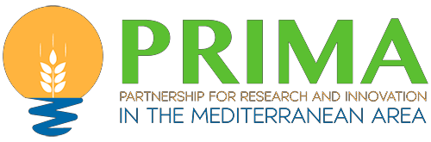

Programme

09h00 : Allocution de bienvenue des organisateurs.
09h30 – 10h00 : Présentation générale du programme PRIMA Focus thématiques des calls PRIMA
Règles de participation et conditions particulières des appels de la Section 1 et la
Section 2.
10h00 – 11h30 Présentation des calls PRIMA 2021
11h30 – 11h45 Pause-café
11h45 – 13h15 Les participants sont appelés à rejoindre l’une des sept (07) « Zoom rooms » en fonction des thématiques / topics qui les intéressent.

Room 1:
Section 1: Thematic Area 1-Water management: Topic 1.1.1-2021 (RIA) Sustainable soil and water management for combating land degradation and desertification and promoting ecosystem restoration.

Room 2:
Section 1: Thematic Area 2-Farming systems: Topic 1.2.1-2021 (IA) Increasing environmental and socio- economic performance of small-scale farming systems through improvements in organisational aspects and new value chain governance models.

Room 3:
Section 1: Thematic Area 3-Agrofood chain: Topic 1.3.1-2021 (IA) Increase adherence to the Mediterranean diet as a sustainable pattern including environmental, social and health aspects.

Room 4:
Section 1: Nexus theme: Topic 1.4.1-2021 (IA) Leveraging knowledge on the Nexus management of Water- Energy-Food-Ecosystems resources in the Mediterranean region: from concepts to practical solutions.

Room 5:
Section 2: Thematic Area 1-Water management: Topic 2.1.1 (RIA) Alleviating Mediterranean water scarcity through adaptive water governance.

Room 6:
Section 2: Thematic Area 2-Farming systems: Topic 2.2.1 (RIA) Up-scaling field practices based on organic agriculture to increase ecosystem services and biodiversity, to adapt the small farming systems to climate change and to increase farmers incomes

Room 7:
Section 2: Thematic Area 3-Agrofood chain: Topic 2.3.1 Increasing the resilience of small-scale farms to global challenges and COVID-like crisis by using adapted technologies, smart agri- food supply chain and crisis management tools.

13h15 – 13h30 Clôture

